B) Uncomfortable Reactions – CISM / Peer Support
4
• Research shows that people will heal and recover faster from stress by responding to stress appropriately; this is the basis of peer support. Peer support can be as informal as "talking it over" with a trained peer. Even if you do not want to speak about the incident there is still value in listening to others speak about it. It is entirely voluntary, but highly encouraged to participate.
• CAP Peer Support can be considered emotional first-aid to help a CAP member’s normal coping skills. It is always confidential, supportive, and respectful; it is performed by a peer supporter – a CAP member just like you who knows how to help you bounce back from stress.
• All people who undergo a traumatic or critical incident are affected. Talking and going through a CISM / Peer Support is a sign of strength and maturity because it means that you are taking an active role in your health.
• CISM/ peer support is a proven process that will help you heal and return to your previous state of health by talking (or listening, if you choose not to talk) about the normal process your mind goes through after an incident or trauma.
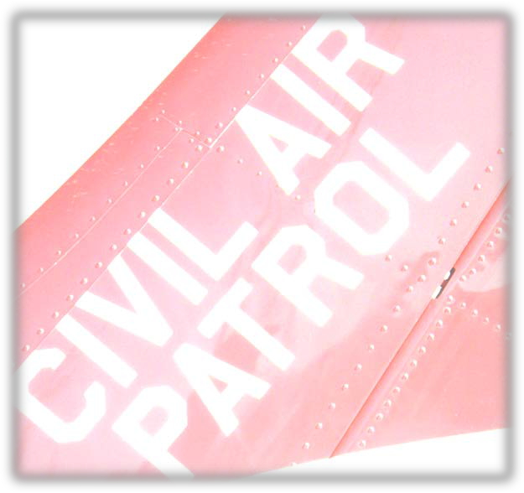
Requesting Help (24x7)
• If you would like to speak with a CAP Critical Incident Stress Management / Peer Supporter contact either:

Region CISM Officer: ______________________________

Wing CISM Officer: ________________________________

NHQ CISM Chief: Lt Col Tom Janisko – (202) 604-7966
CISM@CAPNHQ.GOV

or as a last option, call the CAP National Operations Center-888 211-12812 (24x7) ext. 300; they will coordinate to get the help that best fits your needs.
• If you want to speak confidentially with a suicide phone coach call the suicide prevention lifeline at
1-800-273-8266 or text for free at 838255.
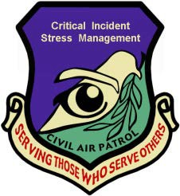
1

Critical Incident Stress Management (CISM) / Peer Support
Alaska Wing Member Death

How did they die?
- There is an active investigation, but the facts we know from the media are that the CAP member made an unscheduled/non-released flight with a CAP aircraft and that the aircraft crashed into the building where their spouse worked in Anchorage, AK.

If this was a controlled and deliberate crash into the ground, it may have been a suicide.

Why do people commit suicide?
- In many cases of suicide, the person makes an impulsive decision, has a “thinking error” where they falsely believe that they will be better off dead or their family will be better off without them, or they want to end emotional or physical pain.
- In this case, the teaching point is to make sure you take a momentary pause and a deep breath before making any life changing decisions. During that momentary pause, your mind will slow down and weigh all options.

How could this death affect me?
- If you knew, or didn’t know the person who died, you may experience some reactions. This is an absolutely normal human reaction and it will disappear over time.

Some reactions include:
• Physical reactions (nausea, fast heartbeat, poor sleep)
• Thinking reactions (difficulty concentrating)
• Behavioral reactions (eating more or less, risk taking)
• Emotional reactions (anger, depression, anxiety)
• For some, Spiritual reactions (feeling disconnected)
This document is for informational purposes only and is not intended to take the place of peer support, counseling, or health advice.

A) Ways to Manage Stress:
2

- Physical Exercise promotes mental and physical well-being as well as excellent management of physical reactions; if you are returning to exercise after a break, make sure your consult your healthcare provider and consider using the 7-minute workout which uses sequential exercises for 30 seconds with a 10 second break in between (creating a 7-minute workout or a 14-minute workout, if performed twice) found at www.7-min.com (additionally there are free apps available). If traditional physical exercise is difficult, consider stretching your body several times a day.

2. Guided Imagery is a technique where a relaxing image such as a favorite peaceful place is used to calm the mind and body. Think of a favorite place, envision yourself in that place, and relax your muscles from your neck to your toes several times a day to relax. Consider using as many senses as possible when doing guided imagery.

3. Spending time with others: being around loved ones and friends who care about you is comforting and can help you adjust to change. Oftentimes they can help you to find balance between the person you are and the change that occurred.

4. Share your story: sharing your story to your loved ones or yourself through journaling or talking to yourself is important to process through the change that occurred.

5. Relation Response is performed by slowly repeating a word or phrase like “slowdown, slowdown, slowdown”), while relaxing your muscles from your neck to your toes, while solely focusing on being more relaxed.

3

6. Diaphragm Breathing is a technique where taking a few breaths relaxes your body. Step 1: breathe in through your nose as you count to 4 and expand your abdominal muscles. Step 2: Hold your breath for 1 second. Step 3: exhale through your mouth and silently count to 8; as you exhale, tighten your abdominal muscles. Repeat 3-4 times; many people feel a sense of relief and peace.

7. People who have faith belief should consider prayer as an excellent method to reduce stress and accept change. Local Religious or Spiritual leaders as well as CAP Chaplains can provide assistance with spiritual guidance, fellowship, and strategies for accepting change.
Chaplain: CAP NHQ Chaplain Corps: 1-877-227-9142

8. Mindfulness Meditation is another excellent method to reduce stress and accept change. Mindfulness Meditation is the idea of having increased awareness of living in the present. You can focus on your breathing, the flow of your breath, as well as your emotions and thoughts. However, you are letting everything pass and not focusing on them.

9. Extra Sleep: Getting extra sleep for a night or two is helpful to “reset” an overtired or stressed “sleep clock”. Many people in their daily life remark that poor sleep is one of the most common reasons for a negative mood. Techniques include:
- No caffeine, nicotine, large meals, bright lights (to include tablets or computers), or exercise for at least 3-hours before bedtime.
- Consider earplugs while sleeping (ensure you can hear the smoke or intruder alarm).
- A short nap is fine; but limit daily naps to 30-45 minutes.
- Consider stretching prior to rising from bed.

