CAP MOU Registration No.

MEMORANDUM OF UNDERSTANDING BY AND BETWEEN
THE CIVIL AIR PATROL BY AND THROUGH ITS ANY STATE WING AND
STATE BY ITS AGENCY

- Purpose. STATE AGENCY and Civil Air Patrol (CAP) wish to utilize the services of CAP and its volunteers for the public good. This memorandum of understanding (MOU) describes the procedures by which AGENCY may request CAP mission support as well as the terms under which missions are authorized, performed, and reimbursed. The memorandum does not, in and of itself, create any legal obligations among the parties or signatories. All previous MOU(s) between CAP and AGENCY are superseded by this agreement. NOTE: No Counterdrug (CD) missions are authorized by this MOU.

- Parties. This MOU is between CAP, by and through its STATE WING, and State AGENCY.

  - Civil Air Patrol. CAP is a federally chartered charitable non-profit corporation. (36 U.S.C. §§40301-40307) Missions flown under this MOU are "corporate missions." Although CAP is not a government agency or military service, it acts as a volunteer civilian auxiliary of the United States Air Force (USAF) when the services of CAP are used by any department or agency in any branch of the Federal Government. Only the USAF can assign "Air Force Assigned Missions" (AFAMs) See Attachment AF for a discussion of CAP's status and missions as the Air Force Auxiliary (10 U.S.C.§§9491,9498) and procedures to request AFAMs.

    - STATE Wing, CAP. WING is an administrative subdivision of CAP and not a separate legal entity from CAP. CAP is generally organized along geographic lines and WING's jurisdiction is defined by the boundaries of the state. Missions under this MOU will be performed by WING. Contact information is included as Attachment A. (The parties may update Attachment A unilaterally by e-mail or other writing.)

    - CAP Members. CAP members are volunteers in public service. Members pay an annual membership fee to join and participate in CAP. "Members," as volunteers are not "employees." Although CAP may have employees in the state, their duties as employees are administrative in nature and do not include participating in CAP missions. WING may use CAP members of units from outside of WING or STATE to perform missions under this MOU. All CAP members shall be deemed members of WING while performing missions under this MOU and entitled to benefits of such membership that arise under this MOU.

    - CAP-USAF. The United States and Civil Air Patrol - United States Air Force (CAP-USAF) are not a party to this agreement. (See Attachment AF)

STATE.

    - STATE Agency. AGENCY is responsible for [describe agency and, where practical cite the statute that designates agency's function and authority especially as they relate to this MOU and missions there under] AGENCY's contact information is provided in Attachment A.

    - Other State or Local Agencies. Other agencies of STATE or local government agencies within STATE that request CAP assistance may submit an abbreviated MOU (such as a letter signed by both parties) that incorporates the terms and conditions of this MOU by reference. An abbreviated MOU should refer to the MOU Registration Number on the cover page of this agreement and attach a copy of this MOU.

    - STATE-WING Relationship. The statutory relationship between STATE (or AGENCY) and WING (or CAP), if any, is set forth in [Cite statute. If none, replace this sentence with "There is no statutory relationship between STATE (or AGENCY) and WING (or CAP.)"]

CAP Mission Capabilities & Limitations.

  - Capabilities.

    - Objectives. CAP provides an organization of private citizens equipped to respond to local and national emergencies and to serve the public welfare. (36 U.S.C.
§40302) CAP can quickly organize large numbers of highly trained volunteers with ready access to up-to-date equipment to provide cost effective support to government agencies.

    - Operations. WING assistance to AGENCY may include and is not limited to: aerial missions such as reconnaissance to search for victims, damage assessments, wildlife, waterways, roadways or environmental surveys utilizing visual, photographic, digital, and video techniques; airborne communications support; and airlift (subject to regulatory restrictions discussed in paragraph 3b). Other support may include: manual labor (e.g. filling sandbags for flood control); radio communications; and ground teams (typically used in search and rescue (SAR) missions). Ground teams are prohibited from participating in CD or other law enforcement missions.

Limitations.

    - Priority of Missions. AGENCY understands and acknowledges that the USAF may withdraw CAP from missions in progress under this MOU when necessary to pursue higher priority missions. This is because CAP is the official auxiliary of the Air

Force, and there is a priority for employing CAP resources which may affect availability of support to state and local authorities. Priority for utilizing CAP resources is as follows: first, USAF, then other DoD departments and agencies, other Federal departments and agencies, state agencies, and finally, local agencies.

    - Law. CAP does not have any special exemption from civil or criminal law. Nothing in this agreement shall be read to require any party or signatory to act in violation of the law or applicable regulations. Furthermore, none of the provisions in this MOU is intended to conflict with applicable laws, regulations, or directives governing CAP missions/activities, including but not limited to those discussed below.

      - Federal Aviation Regulations. Civil Air Patrol pilots, most of whom are private pilots, are required to comply with Federal Aviation Regulations (FARs) The FARs may prohibit private pilots from flying some of the missions (including transport missions except for certain exceptions) contemplated by this MOU. (See Attachment B, CAP Missions and Pilot Limitations)

      - Assistance to Law Enforcement. CAP regulations limit assistance to law enforcement agencies to "passive assistance."

CAP members may not be deputized nor may they take an active part in arrest or detention activities and have no authority to restrict persons by means of force, active or implied.

a. CAP assistance to law enforcement agencies which may lead to criminal prosecution is restricted to patrol, reconnaissance, communications relay and reporting only. Requests for such assistance, unless of an emergency nature, must be approved in advance by the wing and region commanders and coordinated with NHQ/DO via the CAP National Operations Center (NOC) at 888.211.1812 or opscenter@capnhq.gov. All CAP flights will be in accordance with CAPR 70-1, CAP Flight Management.

(CAPR 900-3 paragraph 3a.)

      - CAP Directives. CAP missions and activities are also limited by CAP regulations. CAP personnel are required to comply with CAP regulations. Failure of CAP members to comply with applicable regulations may result in administrative action. (See References below)

    - Risk Management. CAP is an organization of non-paid volunteer citizens. As such, CAP members may decline to participate in missions or discontinue missions at any time. Additionally, CAP may decline or suspend CAP missions for any reason, including but not limited to safety, risk, and liability concerns.

- Emergencies. For emergency missions in which (a) life or property are in imminent peril and (b) local resources are inadequate, please see Attachment AF for criteria and procedures for requesting an AFAM.

- Requesting Missions - In General. Any and all mission requests may be submitted to the NOC at 888.211.1812 or opscenter@capnhq.gov. Reimbursement will be made in accordance with this paragraph and paragraph 7. Corporate missions may include, but are not limited to:

  - Air and Ground Search and Rescue (SAR) Operations. See Attachment AF regarding requests for air and ground SAR operations. If the Air Force declines to accept the mission, CAP may nevertheless accept the mission as a corporate mission.

  - Mercy Missions. Mercy missions refer to the transport of blood, organs, serum, and medical equipment necessary to relieve a specific time-critical, life-threatening situation where commercial transportation is unavailable. For more information on how to request a Mercy mission, contact the Air Force Rescue Coordination Center (AFRCC) at 800-851- 3051.

  - Disaster Mitigation and Relief (DR) Operations. DR missions relate to assistance needed for major disasters or emergencies (including all natural and man-made disasters such as hurricanes, floods, tornados, major storms, earthquakes, oil spills or other environmental disasters). See Attachment AF regarding requests for DR missions. If the Air Force declines to accept the mission, CAP may nevertheless accept the mission as a corporate mission.

  - SAR/DR Training Missions. See Attachment AF regarding requests for air and ground SAR/DR Training Missions. If the Air Force declines to accept the mission, CAP may nevertheless accept the mission as a corporate mission.

  - Homeland Security (HLS). See Attachment AF regarding requests for Homeland Security operations. If the Air Force declines to accept the mission, CAP may nevertheless accept the mission as a corporate mission.

  - Aerial Reconnaissance of Ground Conditions and Surface Traffic for AGENCY. This may include visual or photographic reconnaissance of wildlife, land, forests, roadways and waterways, etc. (Note: In the event of an "environmental disaster," AGENCY may be able to request an AFAM in accordance with Attachment AF). Participation of AGENCY personnel in these aerial reconnaissance missions are discussed in paragraph 5g below.

  - Agency Crewmembers. AGENCY may request CAP aircraft and aircrew as an aerial platform from which AGENCY officials may perform “aerial work,” as "crew members." "Aerial work" includes missions such as aerial reconnaissance of ground

conditions (discussed in paragraph 5f above) or operation of an airborne repeater. AGENCY officials may be authorized to fly aboard CAP aircraft in accordance with CAPR 70-1.
AGENCY officials performing aerial work or duty in the aircraft during flight are crewmembers and not “passengers.”

  - Air Transportation of Cargo and Passengers. Air transport of cargo and/or passengers on corporate missions shall be in accordance with subparagraphs (1) and (2) below. Such missions shall be performed without reimbursement or payment of any kind from sources outside of CAP due to FAA restrictions. (Note: Transport missions may be funded by the CAP pilot or WING but such missions may be limited due to availability of funding):

    - AGENCY Officials/Other Non-CAP Passengers. CAP may transport AGENCY officials and other non-CAP passengers approved in accordance with CAPR 70- 1.

Command, Control, Coordination and Cooperation:

  - Immediate command and control over all CAP resources and personnel employed in accordance with this MOU shall rest with CAP at all times. Mutual consent should be the norm; nevertheless, any party to this agreement may suspend or terminate CAP missions conducted pursuant to this MOU without cause.

  - Both WING and AGENCY agree to maintain continual and effective communication and coordination to facilitate the training necessary for effective CAP participation with STATE emergency service personnel in disaster relief missions.

- Reimbursement. Reimbursement to WING for missions will be as follows:

  - Reimbursement for Corporate Missions. When AGENCY reimbursement is required by WING for missions performed under this MOU, such reimbursement shall be limited to the rates established in the current Civil Air Patrol Regulation 173-3, Payment for Civil Air Patrol Support Attachment 1 (a copy of which is provided as Attachment C and incorporated herein by reference). The parties agree that Attachment C, as revised from time to time by Civil Air Patrol and approved by CAP-USAF, will be the basis for determining reimbursement. Additionally, aircraft and automobile fuel and oil will be reimbursed at actual cost.

  - Restrictions on Billing. Dual payment/compensation or double billing is prohibited and may not be requested or accepted. For example, if WING receives or is offered state funds for aircraft operating expenses (fuel, oil, maintenance), WING may not seek or accept reimbursement for the same expense from CAP National Headquarters, or from any other source (i.e. another federal agency).

Liabilities: Insurance, Workers Compensation & Related Matters.

  - State Protections. State protections afforded CAP and its members such as workers compensation and/or liability protection, if any, are set forth in Attachment D.

  - CAP Protections. In addition to protections afforded in paragraph 8a above (if any), CAP and its members are protected by liability insurance policies as well as member benefits described in CAP Regulation 900-5, Civil Air Patrol Insurance/Benefits Program and 112-10, Indemnification.

  - No Federal Protections. CAP and its members are not deemed to be instrumentalities of the United States while performing corporate missions. Therefore, Federal Tort Claims Act (FTCA) (10 U.S.C. 9442(b) (2); 28 U.S.C. 2671 et. seq.) and Federal Employees Compensation Act (FECA) (5 U.S.C. 8141) do not apply.

Air Force Provisions.

  - The subject MOU is between CAP Corporation and [State Agency] and is not an agreement with CAP as the Air Force Auxiliary.

  - The United States Air Force has priority in the use of CAP equipment bought with appropriated funds. The priority for utilizing CAP resources is: (1) USAF; (2) Other DoD departments and agencies; (3) other Federal departments and agencies; (4) State agencies and (5) Local agencies.

  - CAP volunteers flying missions under this MOU are not eligible for FTCA or FECA benefits.

  - No Air Force Assigned Missions (AFAM) will be assigned pursuant to this MOU.

  - Missions flown and funded under this MOU are not eligible for payment or reimbursement from the federal government.

Effective Date, Term, Termination, and Approval Provisions.

  - Effective Date. The terms of this MOU will become effective as of the date signed by both parties.

  - Term. This MOU shall be effective for a period of five years from its effective
date.

  - Amendment. This MOU embodies the entire terms and understanding of the parties and no other agreements exist between the parties except for those expressly stated herein, to include attachments cited below and executed by the parties. This MOU may be amended by written notice of either party, which expressly identifies itself as a part of this agreement and is signed by an authorized representative of each of the parties. Air Force provisions in this MOU are not subject to amendment or revision by either party. (See paragraph 9 and Attachment AF)

  - Termination. The parties may terminate this MOU at any time upon sixty (60) day advance written notice of termination signed by their designated representatives. Copies of the termination notice shall be mailed to the designated representatives of each of the parties at addresses shown below. (See Attachment A and the addresses below).

National Headquarters, Civil Air Patrol 105 S. Hansell Street
Maxwell AFB, AL 36112

IN WITNESS WHEREOF, this MOU has been executed by the parties herein:

STATE Wing Civil Air Patrol AGENCY NAME

BY BY
John A. Salvador NAME
Chief Operating Officer TITLE

DATED: DATED:

Attachments:

AF Untitled AF Involvement Attachment A Contact Information
- Table: CAP Missions and Pilot Limitations
- CAP Regulation 173-3, Payment for Civil Air Patrol Support, Attachment 1, Reimbursement Rates

References:

Hotlinks to online sources for these citations can be found at:

United States Code http://uscode.house.gov/search/criteria.shtml 10 U.S.C. §§ 9491 - 9498, (Organization and Management of Civil Air Patrol)
36 U.S.C. §§40301 – 40307, Civil Air Patrol

https://www.gocivilairpatrol.com/members/publications/indexes-regulations-and-manuals-1700

CAP Regulation 60-3, CAP Emergency Services Training and Operational Missions CAP Regulation 70-1, CAP Flight Management (replaced CAP R60-1, 4 Dec 17) CAP Regulation 112-10, Indemnification
CAP Regulation 173-3, Payment for Civil Air Patrol Support
CAP Regulation 900-3, Firearms - Assistance to Law Enforcement Officials
CAP Regulation 900-5, Civil Air Patrol Insurance/Benefits Program

Attachment AF

AIR FORCE ASSIGNED MISSIONS

- The following are potential Air Force Assigned Missions (AFAM):

  - Air and Ground Search and Rescue (SAR) Operations. CAP, as the Air Force Auxiliary performs SAR missions to search for, locate, and relieve a distress situation, including overdue aircraft, emergency locator transmitters (ELTs), and persons in distress. For more information on how to request an AFAM SAR mission, contact the Air Force Rescue Coordination Center (AFRCC) at 800-851-3051.

  - Mercy Missions. Mercy missions refer to the transport of blood, organs, serum, and medical equipment necessary to relieve a specific time-critical, life-threatening situation where commercial transportation is unavailable. For more information on how to request a Mercy mission, contact the Air Force Rescue Coordination Center (AFRCC) at 800-851- 3051.

  - Disaster Mitigation and Relief (DR) Operations. DR missions relate to assistance needed for major disasters or emergencies (including all natural and man-made disasters such as hurricanes, floods, tornados, major storms, earthquakes, oil spills or other environmental disasters). For more information on how to request a Disaster Mitigation and Relief mission, contact the Air Force National Security Emergency Preparedness (AFNSEP) duty officer at 800-366-0051.

  - SAR/DR Training Missions. SAR/DR training missions are joint training missions with CAP and the State Agency. For more information on how to request a SAR/DR training mission, contact the appropriate Assistant Director of Operations.

  - Homeland Security (HLS). Department of Defense and Air Force policy on HLS missions CAP may be tasked to perform in support of civil authorities is still evolving. For more information on how to request a Homeland Security mission, contact the CAP National Operations Center (NOC) at 888-211-1812 or opscenter@capnhq.gov.

- For information on any other above AFAM, you may also contact the NOC at 888-211- 1812.

Attachment A

CIVIL AIR PATROL CONTACT INFORMATION

CIVIL AIR PATROL
Contact Information as of
MISSION | CONTACT | PHONE & E-MAIL* | ADDRESS
Homeland Security (HLS)  (MOU Paragraph 5e) | CAP National Operations Center | W: 888.211.1812/ 334.953.5823/ DSN 493-5823  F: 334.953.4242  DSN 493.4242  E: opscenter@capnhq.gov

STATE AGENCY CONTACT INFORMATION

STATE AGENCY
Contact Information as of
MISSION | CONTACT | PHONE & E-MAIL* | ADDRESS
Planning & Miscellaneous |  | W:  F:  H:  P:  C:  E:
Billing |  | W:  F:  H:  P:  C:  E:
Operations |  | W:  F:  H:  P:  C:  E:

Attachment B

TABLE: CAP MISSIONS AND PILOT LIMITATIONS

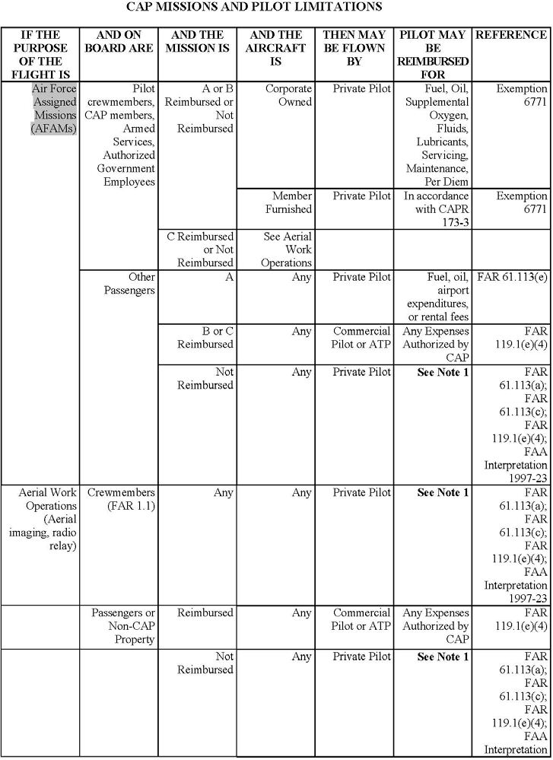

Attachment B

TABLE: CAP MISSIONS AND PILOT LIMITATIONS (cont’d)

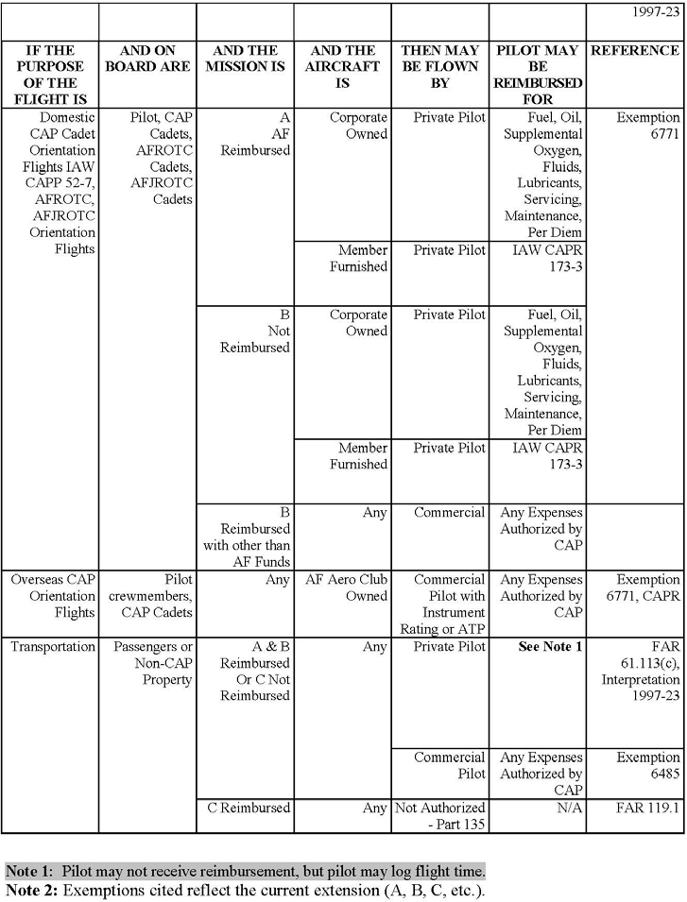

Attachment C

CAPR 173-3, ATTACHMENT 1, REIMBURSEMENT RATES
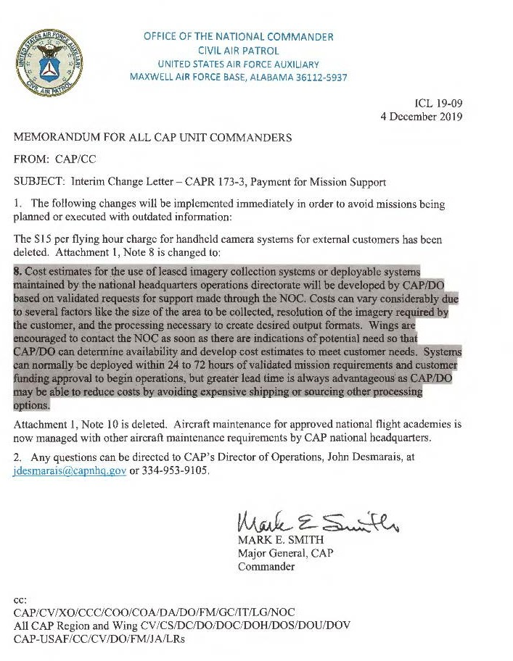

Attachment C
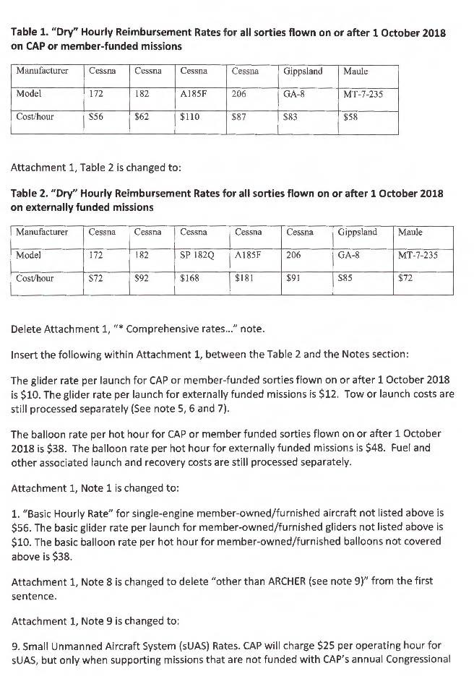
CAPR 173-3, ATTACHMENT 1, REIMBURSEMENT RATES. cont’d

Attachment C
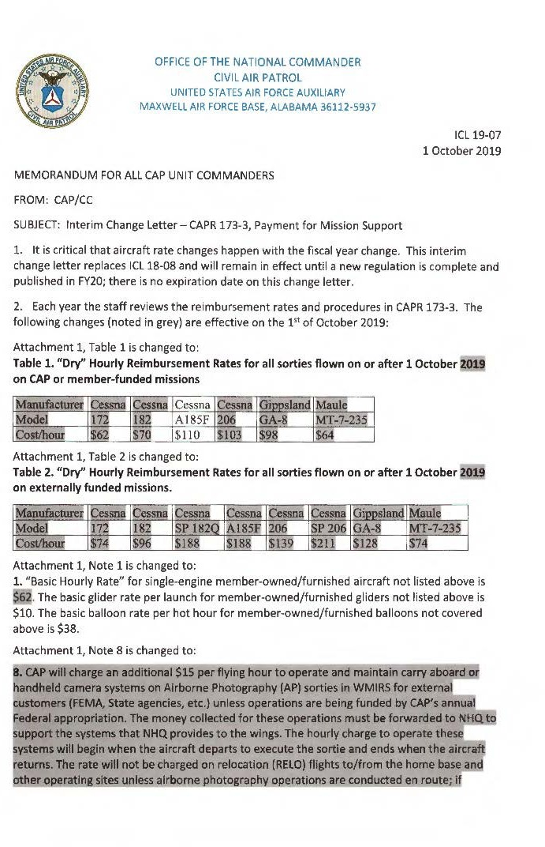
CAPR 173-3, ATTACHMENT 1, REIMBURSEMENT RATES. cont’d

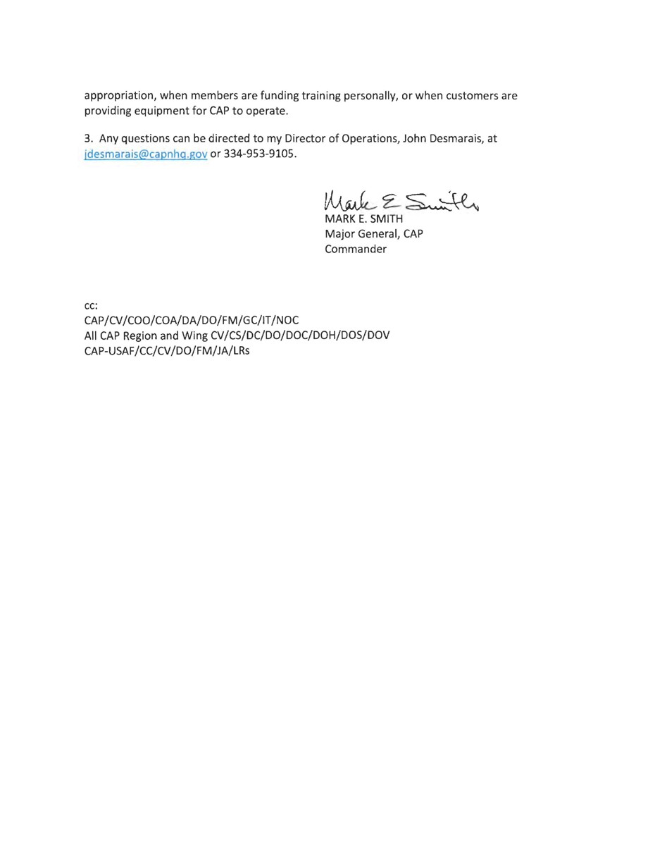
Page 16 of 20
Attachment C
CAPR 173-3, ATTACHMENT 1, REIMBURSEMENT RATES. cont’d

Attachment C

CAPR 173-3, ATTACHMENT 1, REIMBURSEMENT RATES (cont’d.)

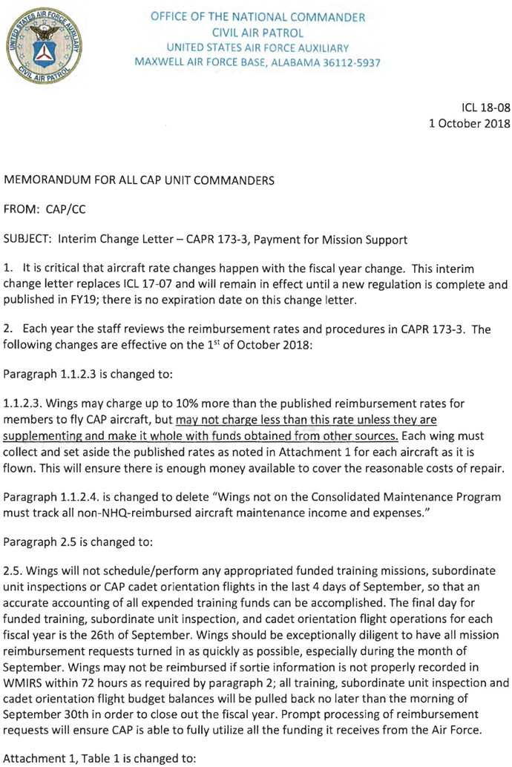

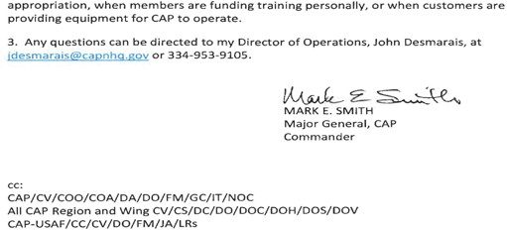
Attachment C
CAPR 173-3, ATTACHMENT 1, REIMBURSEMENT RATES (cont’d.)

ATTACHMENT D

STATE PROTECTIONS AFFORDED CAP & MEMBERS

Confer with your legal officer to ensure that state protections, if any, are described here in detail adequate to bind State and are detailed somewhere adequate to explain it to the people in the field. A supplement to CAPR 900-5 may be in order. The following issues are submitted for consideration:

- General.

  - This list is not intended to be a tool for negotiation. It is simply a request for whatever protections State already has available or to which State may already have ready access. If State is unable to provide any protections, that factor becomes part of the commander's risk analysis and decision making processes as s/he considers whether to undertake the MOU or any specific mission.

  - The point is NOT that CAP has no insurance or lacks coverage; our insurance is adequate. Rather, the goal is to minimize the exposure of CAP and its insurer(s) so as to and minimize the increase of our insurance premiums (and the potential for loss of coverage) brought about by losses and protect corporate assets. As a general proposition, CAP flies missions in support of states "at cost," the known costs of doing business. The protections discussed in this attachment form part of the "unknown costs," the hazards incurred performing these missions. It is reasonable to ask that this cost be born by our "customer."

  - Watch for gaps in protection and coverage.

- Specific issues: For each and every mission, consider:

  - Liability & Indemnity. Will state provide indemnity/liability coverage? Is such indemnity in lieu of CAP's other coverages (e.g. insurance, FECA, or FTCA)? Is any action by the member required in order to be eligible? (e.g. Registration as a Disaster Services Worker.) Does STATE indemnify each category of "person" below for actions arising in the course missions?
    - All members (cadets and senior members) regardless of age. (Remember, FECA benefits are not available for members under age 18.))
    - All members, including those not participating in the mission (e.g. Wing Commander, who holds overall responsibility or other members whose only contact may have been managing aircraft maintenance or planning, preparing and training for such missions)?
    - Civil Air Patrol, itself.
    - All agents, principals. . . etc. of CAP?

Is any specific action required of CAP in order to be eligible? (e.g. Obtain a state mission number.)

  - Immunity. Is statutory immunity available ? Is such immunity in addition to or in lieu of CAP's other coverages (e.g. insurance)? Is any action by the member required in order to be eligible? (E.g. Registration as a Disaster Services Worker.) Does STATE immunize each category of "person" below for actions arising in the course missions?
    - All members (cadets and senior members) regardless of age. (Remember, FECA benefits are not available for members under age 18.))
    - All members, including those not participating in the mission (e.g. Wing Commander, who holds overall responsibility or other members whose only contact may have been managing aircraft maintenance or planning, preparing and training for such missions)?
    - Civil Air Patrol, itself.
    - All agents, principals. . . etc. of CAP?

  - Workers' Compensation. Does STATE provide workers compensation benefits and protection to each category of "person" below for actions arising from missions?
All members (cadets, senior members) regardless of age? (As you know, FECA benefits are not available for members under age 18.))
Civil Air Patrol, itself (e.g. protection from suits by members under the "exclusive remedy" provision afforded by some workers' compensation laws.)
All agents, principals. .. etc. of CAP afforded the protection from suits by
members?
Is any action by the member required in order to be eligible? (e.g. Registration as a Disaster Services Worker.)
Is any specific action required of CAP in order to be eligible?

  - Workers' Compensation. Apart from the MOU, are volunteers considered "employees" or afforded the benefits of workers compensation from their respective organizations? Are organizations required to provide workers compensation coverage? Are organizations afforded the protections (e.g. "exclusive remedy") of workers compensation?

