DORMITORY STANDARDS
  - Dormitory Behavior Expectations
    - Cadets will move to the side and stand at attention in passageways to allow cadre officers to pass and parade rest for cadre NCOs. Cadets will not come to attention if it is unsafe to do so, (such as while on stairways,) but will allow cadre members to pass and issue the greeting of the day.
    - When an officer enters a room, cadets will call the room to attention.
    - Unnecessary noise and loudness will not be permitted at any time.
    - Dormitory areas will be kept clean and in inspection order between the hours of 0730 and 2100 daily. ‘Inspection order’ means free from dirt and with clothing, beds, and other material in accordance with SET standards.
      - Uniforms will also need to be in inspection shape, during these times. Check with wingmen to ensure this standard is met.
    - Cadets must sleep in their own beds, between the sheets. You will remain in your bed between Lights Out and First Call, with the exception of using the latrine or an emergency.
    - Cadets will sleep in a head-to-toe arrangement.
    - There will be NO talking after lights out. If cadets must leave their bunks to use the latrine they will use the latrine and proceed directly back to their beds.
    - Cadets will be familiar with SET prescribed procedures found later in this section.
    - Scores from daily inspections will be posted in the respective hallway. Make note of any comments left by the inspecting party.
      - If there are any questions or concerns about your score, please discuss this with your flight cadre.
      - Uniform Inspections will also be conducted during room inspections and the uniforms of cadets will need to be checked before rooms are inspected.
    - Cadets will turn the lights off when leaving the room.
    - Windows are to remain closed at all times unless specifically instructed by staff to open them.
    - Deadbolts should remain open at all times and dorms should never be locked.
  - Dormitory Standards
    - NAME TAGS
      - All beds, closets, dressers, and doors will be designated using name tags. All name tags will be completed using the following format:
        - Name tags in the closet will be in a different format, that is:
        - Last Name, First Initial
      - Any bed, closet, dresser, or door without a properly displayed and formatted name tag will receive a failing score. Name tags will be placed as such:
        - On the bed, the name tags will be posted on the wood post closest to the door with the bottom of the name tag in line with the bottom of their respective mattress.
        - In the closet, the tags will be placed in a row, from left to right, centered on each section of hangers, slightly above the clothes hanger bar.
        - On dressers, tags will be placed on the top of the drawer unit. Cadets will order name tags such that the cadet using the top left and top right drawer has their tag one inch away from the top and one inch from the right side. Each following tag will be placed one inch below (ex. the cadet using the second-from-the-top left and right drawers will have their name tag placed under the name tag of the cadet using the top drawers).
        - On the desk, the name tags will be placed in the top left corner, an inch from the top and side, in alphabetical order by last name. All following tags will be placed an inch below.
        - On the door, the tag will be centered on the doors with the highest card 1 inch below the room number plaque. The tags will be placed in alphabetical order by last name and each one will be 1 inch below the card above it.
    - BUNKS
      - The mattress will be flat against the headboard. Bed rails will be clean and free of dust. Both sides of the mattress are subject to inspection.
      - Bottom sheet - Drape evenly over the mattress. Tuck extra material under the mattress. The sheet should be tight with no wrinkles.
      - Top Sheet - Drape evenly over the mattress on top of the bottom sheet. Pull it up until the top edge of the sheet is approximately 6 inches from the head of the mattress. Tuck any excess under the end of the mattress.
      - Blanket - Drape evenly over the other two layers. Pull up until the top edge is approximately 6 inches from the head of the mattress. Tuck any excess blanket under the bottom end of the mattress.
      - Hospital Corners - Use hospital corners to tuck in excess material. First, grasp the side of the sheet approximately 12 inches from the corner in which the hospital corner will be made. Pull the sheet at a 45-degree angle from the corner and tuck excess underneath the mattress. Next, grasp the 45-degree angle and without changing its shape, bring it down and tuck underneath the mattress. After tucked, smooth and tighten to the conformity of the mattress. Hospital corners need only to be made at the foot of the bed.
      - White Collar - Fold the top sheet and blanket over together to form a 6-inch white collar. Fold both over again so that the top of the collar is 18 inches from the head of the mattress. Tuck excess material underneath the mattress, including the collar itself. After tucked, smooth and tighten to the conformity of the mattress.
      - Pillow and Pillowcase - Put the pillow inside the case and place it on the bed, open side to the right with the excess material neatly folded underneath, centered at the head of the bed, and centered on the width of the mattress
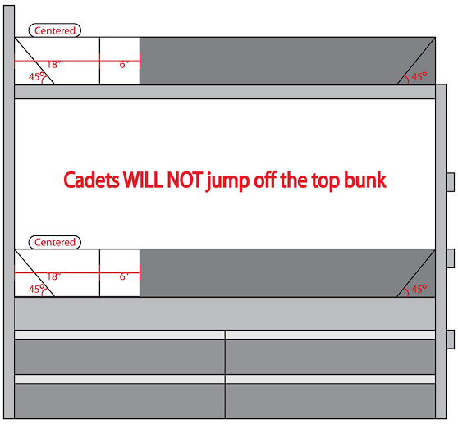

      - Laundry Bag - The laundry bag will remain closed and pulled tight when not in use. The bag will be hung from the bedpost at the foot of the bed and tucked underneath the bed if possible. The bag belonging to the cadet on the top bunk will be hung on the left bedpost and the laundry bag for the cadet on the bottom bunk will be hung on the right bedpost.
      - Towels - Towels will be hung on the rails at the foot of the bed. They will be hung in a way that looks neat, while allowing the towel to dry between showers. Both ends of the towel will be in front of the rung below the one it is hung on. The cadet on the top bunk will place their towel on the top rail and the cadet on the bottom bunk will place their towel on the next exposed rail beneath the first towel. The bottom towel will not touch the floor and may be moved up a rail if necessary.
    - SHOES
      - Keep all shoes clean, dry, shined if need be, and serviceable. If an item becomes unserviceable, notify a member of your flight cadre. Tightly lace all shoes/boots not being used. “Tightly laced” shoelaces will be pulled closed as tightly as possible without being tied. Tuck excess laces inside the shoe, out of sight.
      - Order of Display - Cadets will place their shoes under the bed with the fronts grounded to an imaginary line parallel to the side of the bed. If in a bunk bed, the top bunk cadet will align their shoes to the left of the bottom bunk cadet’s shoes. Shoes will be placed in the following order: Combat boots, dress shoes, athletic shoes, shower shoes. The row of shoes will be grounded to the most accessible bedpost as close as possible, without protruding from underneath the bed.
      - Alignment - Ensure that the toes of shoes are grounded at the fronts. Keep shoes as perpendicular to the imaginary line as possible. Leave a space when wearing a pair of shoes.
    - FOLDING/ROLLING PROCEDURES
      - Displayed items must be worn; they are not for display purposes only. You must properly size all items from top to bottom to front of drawer to back. Remove loose tags or strings. Do not remove sewn-in tags. Do not starch drawer items. If you do not have an item for display, leave a space where the item would have been displayed.
      - Socks - Roll all socks in the following manner:
        - Roll socks in pairs.
        - Lay a pair of socks (right side out), one on top of the other with the open end away from you, and one sock offset by two inches.
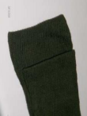
        - Starting with the toes, tightly roll towards the open end.
        - Fold the open end of the bottom sock back over the entire roll securing it.
        - The open end of the socks will be flat with no excess sticking out past the roll.
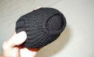
      - T-shirts - T-Shirts will be folded as follows:
        - Lay the T-shirt flat with the collar down and to your right. Ensure edges are even.

        - Fold the shirt in half. Start with the side closest to you and fold away from you.
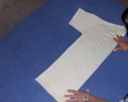
        - Fold the sleeves towards you until the shirt forms a rectangle. 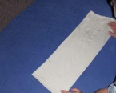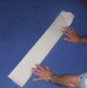
        - Starting from the side furthest away from you, fold the T-shirt in half towards you.
        - Tightly roll the t-shirt starting from the waist towards the collar. Ensure you keep edges even.
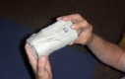
      - Shorts and Underwear
        - Lay flat with the front down, waistband away from you. 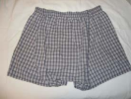
        - Fold in half from crotch to waistband. Fold in half from leg openings to waistband. Crotch should be even with the top of the waistband. Fold excess over to make the top even.
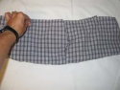
        - Square by folding the sides neatly to the center. 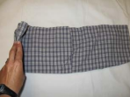
        - Starting with the left side, fold in equal thirds from left to right. Ensure you keep edges even as you fold. Excess material may be tucked in to square the edges. For shorts, fold in half from left to right.
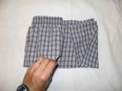
        - When folded properly (with the front facing up), there will be a single fold on the left. The open end will be to the right. Edges will be even.
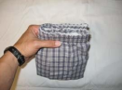
      - Bras
        - Place one cup inside the other cup. Make sure the single fold is on the left.
        - Tuck the straps and the back of the bra completely inside the cups 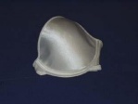
      - Sports Bras
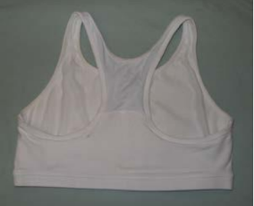
        - Lay the bra flay with the front down and the straps away from you.

        - Fold the straps down until flush with the bottom edge of the bra. 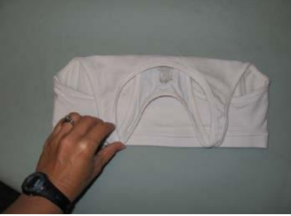
        - Fold the bra from left to right, keeping all edges even. Single fold will face the left.
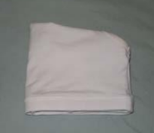
    - CLOSETS
      - Keep the closet clean and dust free. Keep all items clean, dry, pressed, folded, serviceable, and displayed properly. Display items as worn (zipped, snapped, buttoned, pressed, etc.), unless otherwise directed. Display items right side out.
      - The student on the top bunk of the leftmost bed will hang their clothes on the left side of the closet. Uniforms will be hung from left to right in the following order: Blues slacks/skirts, Blues blouse(s), ABU trouser(s), and ABU blouse(s). The name tapes/plates will face the center of the closet. If there are two closets in the room, the cadet on the bottom bunk will hang their clothes on the right, mirroring the first cadet’s uniforms (Blues pants furthest back and name tapes facing center). If there is only one closet, uniforms will be hung in the same way, however, the cadets on the left bunks will hang their clothes on the left and the cadets on the right bunks will hang their clothes on the right.
      - Hanger Management - Hang all hangers with the open end of the hook facing the rear of the closet. Hang all items separately. No more than three “extra” hangers per cadet are authorized. These hangers should be used for replacement purposes. Display extra hangers as one, grounded to the wall of the closet. Leave 5 inches of space in the center of the closet and space the uniform items evenly across the appropriate part of the closet. When spacing the uniforms, the goal is to keep it orderly and as accessible as possible. Space them out with a reasonable amount of space, depending on how many cadets’ items are in that closet. When the uniform is being worn, leave the empty hangers in the place they would be if the uniform was on them.
    - DRESSERS
      - Each cadet will have two drawers in the dresser. Cadets in bunks on the left side of the room will use the top half of the dresser and the cadets in bunks on the right will use the bottom half of the dresser. Cadets in top bunks will use the top drawers and those in bottom bunks will use bottom drawers in their set. If there is only one bunk, use the top two drawers.
      - Left Drawer
        - Underwear - Place folded underwear so that it is grounded to the top left corner of the drawer with the waistband opening facing the top of the drawer. The next additional pair being displayed will be placed in front of and grounded to the first pair. The next pair will be placed in front of and grounded to the second pair. All subsequent pairs will be stacked neatly on top of original rows.
        - Boot Socks - Place rolled pairs of socks grounded to the front edge of the drawer. The opening of the sock will face the right side of the drawer. Place each one grounded at the edge to the pair before and the front edge of the drawer. If a second row is needed, place the row behind and ground to the first row. If more than two rows are needed in the drawer, the third row may be stacked on top, centered between the first and second rows. If more space is needed in the drawer for bras, the second row may be stacked on top of the first and grounded to the front of the drawer.
        - Athletic Socks - If there is an incomplete row of boot socks, complete the row in the same manner and then follow these instructions. Place rolled pairs of socks grounded to the right edge of the drawer and the last row of boot socks. The opening of the sock will face the right of the drawer. Place each pair behind and ground to the previous pair until the column reaches the back of the drawer. If a second column is needed, ground the column to the first row and the last row of boot socks. If a third column is needed, it may be stacked on top, centered between the first and second columns.
        - Blues Socks - If there is an incomplete column of athletic socks, complete the column in the same manner, then follow these instructions. Create a row between underwear and athletic socks in the same manner as the row(s) of boot socks. Ground the rows to the boot socks, athletic socks, and underwear. If another row is necessary, ground the new row to the previous row. If more space is needed for bras, blues socks may be placed in columns in the same manner as the athletic socks on top of the first column of athletic socks.
        - Bras - Place folded bras with the top of the garment grounded to the back edge of the drawer, between underwear and athletic socks. Stack each garment on top of the previous. If a second stack is needed, place in front of the previous stack, with the top of the second grounded to the bottom of the first.
      - Right Drawer
        - ABU Shirts - Ground the first shirt to the front edge and left wall of the drawer with the “flap” edge facing down. Place each shirt behind the previous one until the last one is grounded to the back left corner of the drawer. If necessary, a second column may be placed on top of the first.
        - White Shirts - Ground the first shirt to the front edge of the drawer and right edge of ABU shirts with the “flap” edge facing down. Place each shirt behind the previous one until the last one is grounded to the back left corner of the drawer. If necessary, a second column may be placed on top of the first.
        - Athletic Shorts - Ground the first pair of shorts to the front edge of the drawer and right edge of white shirts with the waistband facing the top of the drawer. Place each pair behind the previous one until the last one is grounded to the back left corner of the drawer. If necessary, a second column may be placed on top of or next to the first.
      - Top of the Dresser
        - The cadet on the top left bunk will place their flight cap parallel to the edge of the left side of the dresser, one inch from the left edge and one inch from the back. The device will be facing up towards the front edge of the dresser with the flight cap opening towards the right. The ABU cover will be placed centered left-right on top of the flight cap, with the bill facing the front of the dresser. The back of the ABU cover will be grounded to the back edge of the flight cap.
        - Each following flight cap will be placed to the right of previous flight caps in an identical manner with equal spacing. The order left-to-right will follow the order of name tags on the dresser top-to-bottom.

    - DESKS
      - Top of the Desk
        - The facility-issued Bible will be grounded to the upper left corner of the desk. If there are multiple Bibles present, they will be neatly stacked. Do not misplace the Bible, as it is facility property.
        - Items will be organized in the following manner: The cadet on the bottom bunk on the right side of the room will place belongings on the right side of the desk. The cadet on the top bunk on the right side of the room will place belongings on the left side of the first cadet’s belongings, while staying on the right half of the desk. The cadet on the top bunk on the left side of the room will place belongings on the left side of the desk, grounded one inch to the right edge of the facility-issued Bible (if present). The cadet on the bottom bunk on the left side will place belongings to the right of their bunkmate’s belongings.
        - Shaving cream - Display grounded against the back of the desk. Display with the spout facing the front of the desk.
        - Shampoo - Display in the same manner as the shaving cream, grounded to the shaving cream and the side edge if appropriate. If there is no shaving cream, ground to the back edge of the desk.
        - Conditioner - Display in the same manner as the shaving cream, grounded to the shampoo and the side edge if appropriate.
        - Body Wash - Display in the same manner as the shaving cream, grounded to the conditioner and edge of the desk if appropriate. If there is no conditioner, ground to shampoo. If the body wash is a bar soap, place it in front of the deodorant instead.
        - Deodorant - Display in the same manner as the shaving cream, grounded to the body wash and edge of the desk if appropriate. If the body wash is a bar soap, ground to the conditioner or shampoo.
        - Soap Dish/Bar Soap Container - Display grounded to deodorant and edge of the desk if appropriate.
      - Desk Drawer
        - The desk drawer may be used as a personal drawer for all cadets in the room. Be courteous and do not use more than a fair amount of the drawer. The blues belt, the ABU belt, and blousing bands will be stored here or in luggage. Other items that may be stored in this drawer include other hygiene and miscellaneous items not already stored such as toothbrushes, hair brushes and other hair materials (bobby pins, hair ties, etc), and any other personal accouterments. This drawer will not be graded individually but is subject to visual inspection that will contribute to the overall neatness of the room.
      - Additional Belongings
        - Extra Luggage - All extra luggage will be closed and placed such that it is grounded to the wall and head of the bed. Additional luggage pieces will be grounded to the left of the first item against the wall. If there is no room, additional luggage will be placed under the bed, out of sight.
        - Miscellaneous Clothes - All other clothing items not specifically prescribed or that do not fit in the dresser will be kept in luggage.

